Me llamo ________________________ hora _____ fecha _______________
Tener y Tener Idioms
I. Fill in the chart below with the correct forms of the verb Tener. Use your book or vocab sheet for help if needed.
Yo |  | Nosotros/as
Tú |  | Vosotros/as
Él, ella, ud. |  | Ellos/as, uds.

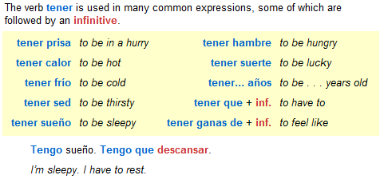
II. Use the chart above and the information in the chart below to translate the following sentences into Spanish.

*Remember an infinitive is a verb that ends in ar, er, ir (not conjugated)
1. I have the book. ______________________________________________________
2. She has the pen. ______________________________________________________
3. We are in a hurry. _____________________________________________________
4. He is thirsty. _________________________________________________________
5. They (g) feel like dancing._______________________________________________
6. You have to study. ____________________________________________________

