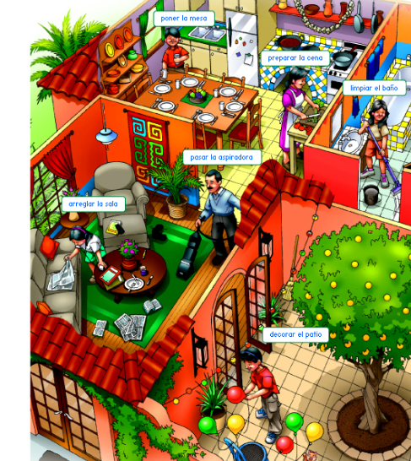
Present Progressive-El Presente Progresivo
Julio
Lucia
Manuel
Papá
Mi madre mademm=maddre
Sara
Translate the following sentences into Español using the present progressive:
Estar + -ando/-iendo

1. My mom and Julio are working in the kitchen.______________________________________
2. Julio is setting the table.____________________________________________________
3. My mom is preparing dinner._________________________________________________
4. Lucia is fixing up the living room.______________________________________________
5. Papá is vacuuming.________________________________________________________
6. Sara is cleaning the bathroom.________________________________________________
7. Manuel is decorating the patio.________________________________________________
8. I am learning Spanish! ______________________________________________________

