Me llamo ________________________ hora _____ fecha ____________
Los Mandatos Informales con los pronombres directos
Informal Commands with DOPs
Using vocabulary from section 1.2 write an informal command with a direct object pronoun (DOP) for each picture shown. The English command is given with the picture as a clue.
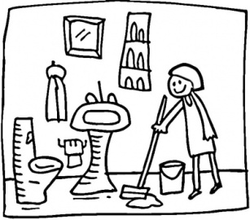

Set it! (the table) Clean it! (the bathroom)
_______________ _______________
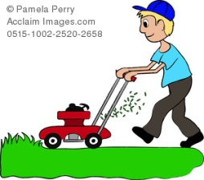

Cut it! (the grass) Take it out! (the trash)
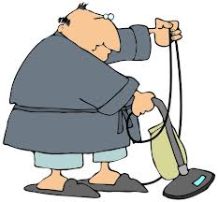
_______________ ________________
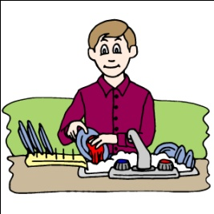

Wash them! (the dishes) Vacuum it! (the living room)
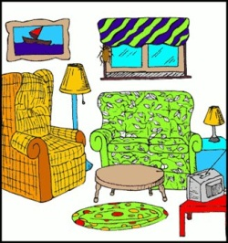
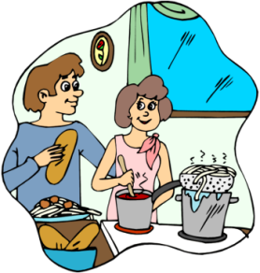
_________________ _________________

Prepare it! (the dinner) Fix it up! (the living room)

