Nombre_____________________________________________________ Hora___________

***Traduzca, por favor. Translate, please.***

***(All use –car, -gar, or –zar verbs in the past tense and the new 3.1 vocabulary).***

1. I paid the hair dresser at the hair salon yesterday. ___________________________________________________
2. I looked for fish at the fish market. ___________________________________________________
3. I touched the monument in the plaza. ___________________________________________________
4. I ate lunch next to (cerca de) the pastry shop. ___________________________________________________
5. I arrived early to the market. ___________________________________________________

***Dime qué está mostrado(shown) en las imágenes y el nombre de las personas que trabajan allá. What picture is shown and who works there?***

 

[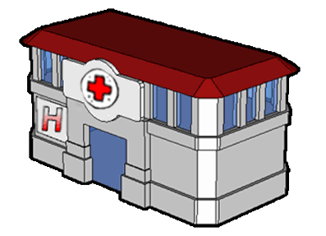](http://www.google.com/url?sa=i&rct=j&q=&esrc=s&frm=1&source=images&cd=&cad=rja&docid=696m_GmK_BvZsM&tbnid=44dz3RbdIqOlJM:&ved=0CAUQjRw&url=http://www.kidney-cares.org/news/904.html&ei=kvFGUf72Fa_8yAGGjoDIAw&psig=AFQjCNF6CvXW8KreSE0HgOY1iAdkDulT9g&ust=1363690221379913)

[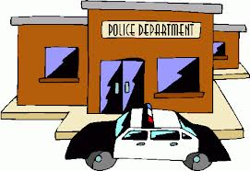](http://www.google.com/imgres?hl=en&biw=1382&bih=773&tbm=isch&tbnid=YPW3vjimYaKPTM:&imgrefurl=http://www.clipartheaven.com/show/clipart/police_&_fire/police_station_3-gif.html&docid=_9a4NI4CZDSs1M&imgurl=http://www.clipartheaven.com/clipart/police_%26_fire/police_station_3.gif&w=490&h=336&ei=IfFGUcHVO-qPyAHuuIDwAw&zoom=1&sa=X&ved=0CKQBEIQcMAU&ved=1t:3588,r:5,s:0,i:164&iact=rc&dur=9845&page=1&tbnh=178&tbnw=259&start=0&ndsp=15&tx=157&ty=56)