Alfabeto y bandera
Project

With your seat partner you are to work together and create the two items below:
- Spanish Speaking Country Flag
-Your group’s assigned country is: _______________________
-Color the flag neatly so that it looks like the real thing.
-Look up the capitol and put it on the back of the flag.

- Alphabet Letter sign
-Our assigned letter is __________
-A full size picture of the letter
-the phonetic sound of how the letter is pronounced
-a word and picture of a Spanish word that begins with the letter.
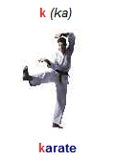
-see an example below:

